**WISDOMWHERE GUIDE**

How to Create an Event Session

**Note: You cannot build a session until your event has been approved.**

Logon using your admin credentials.

Under Mainenance select Event Session.You may need to use the Search Events box to locate your event.

Then click Add New.

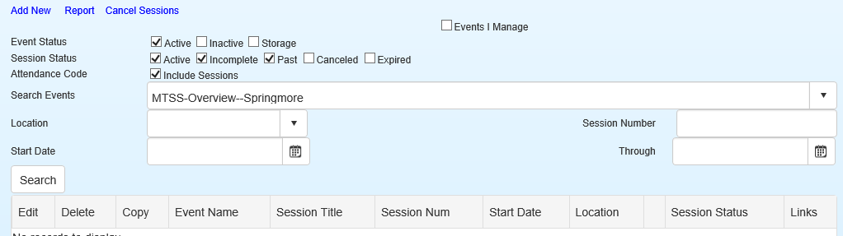

Bold Items are required fields. See explanations below.

\****Italics –*** This indicates required fields that are pre-populated and that you skip.

***\*Event* –** The title of your event is pre-populated.

\****Session Title***-This field is not required, but can be helpful, particularly if your event is offered over multiple days with a different session built for each day.

**\**Sort Order* –** This is set to zero. No change needed.

**Maximum Participants** – enter the number of participants that can register.

***Reminder Email Conf:*** Please select Upcoming Event Email Reminder if you would like to send a remidner to registratnts a day or two before your session. You will need to enter a value in the Send Reminder Email ____ days prior to session Start date field.

**Location** – Use the drop down menu to select your school or other location.

**Add Dates –** Enter the number of dates this event will meet and click select.

Enter the date(s), start and end times.

Registration Cut-off Date: This field is not required, but recommended. Setting this date to the last teacher workday of the year will allow flexibilty for individuals that forget to register.

**Track Attendance –** The default is Over All and this should be used if your session is only one time, one day.

If your session meets multiple days/times AND it will be possible for indivdiuals to receive credit if they end up attending some, **but not all** of the sessions AND, regardless of which session(s) they attend they will receive same type(s) of renewal credit, select Daily (Partial Unit). Examples might include monthly faculty meetings, PLC meetings, etc. Attendance codes should not be used with Daily (Partial Unit).

For RARE occasssions where your event meets multiple days/times, AND registrants (attendees) must attend EVERY TIME to receive ANY credit, then select Daily.

If your event will meet over multiple days/sessions AND you would like to use the Attendance Code feature mentioned below for each separate session OR different credit types are connected to the session days/times, it would be best to build each session separately under your event.



If you select Daily(Partial Unit), you will see a new column, Partial Unit, which allows you to determine what percentage each day/time is worth of the total session. You will need to enter decimal numbers that total 1.0. In the example below, there are three equal-length dates/times, each is worth 1/3 of the total session (.33). To make the total amount equal 1.0, the last session is set to .34.

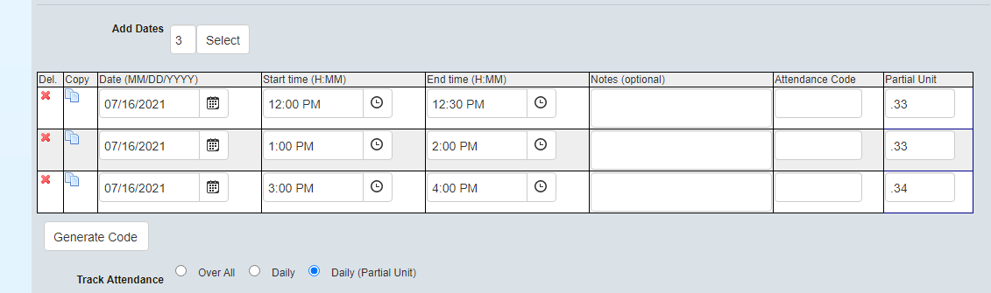

**Generate Attendance Code-**A code used in conjuction with an evaluation to automatically mark attendence. To use this feature, an evaluation must be assigned. This feature SHOULD NOT be used with the Daily (Partial Unit) choice for tracking attendance.

***This feature is not enabled until you assign an evaluation type to the session (See below in Evaluations). You will have to come back to this feature at that point to generate the attendance code.***

If you use this feature, provide your attendees with the code(s) for the session. After the session, the attendees will have an evaluation assigned in the system. On the evaluation page, they will need to enter the attendance code to unlock the evaluation. Once the evaluation is complete, their attedance will automatically be marked!

**Display Start Date -** The date the system will begin to display the session. Defaults to the date the sessions is created.

**Display Start Time** – The time on the start date the session will begin to display. Defaults to 6 a.m.

**Display End Date –** The date the system will stop publicly displaying the session.

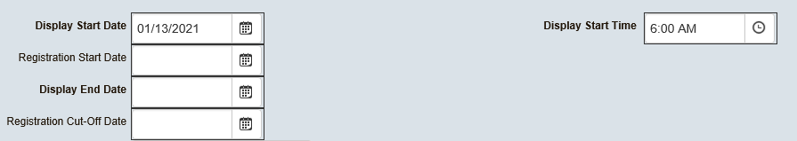

**Registration Start Date** – The day registration can begin. If not filled in, registration is open as soon as the session information is complete and saved.

**Registration Cut-Off Date** – The date the system will no longer allow registrations to be created. If no date is selected, registration will close on the display end date.

**Add Credit Type –** Initially, select the number of credit types (Content area, Digital, Literacy, etc.) that will be awarded for the session. For example, if the session will result in Digital Learning and Liteary credits, you would enter “2” in the box.

After you click Select the number of Credit Types, you will enter the amount of credit for each credit type for the session. You will enter the units, select the type from the drop down menu, and enter the hours. For example, 2 hours equals 0.2 units, 6 hours equals 0.6 units and 10 hours equals 1.0 units. **The unit amount,** is the most important--that is amount that will be posted as CEU credits. If the unit amount is left blank, no credit will be awarded for the session regardless of the number of hours assigned it.

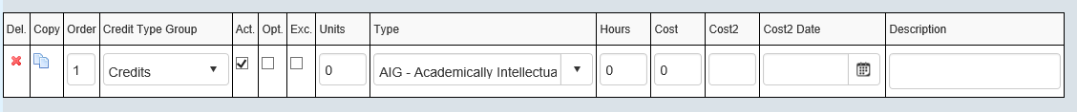

\****Evaluations –*** Typically, you will choose CCS template from the Evaluation drop-down list and check “Yes” to Require Evaluation. Select “Evaluation Required” for the initial Evaluation Email that will be sent to inform particpants they have an evaluation to complete. Additionally, select “Evaluation Reminder” and choose the number of days to send the reminder if you would like the system to automatically remind participants they have an evaluation to complete for the session.

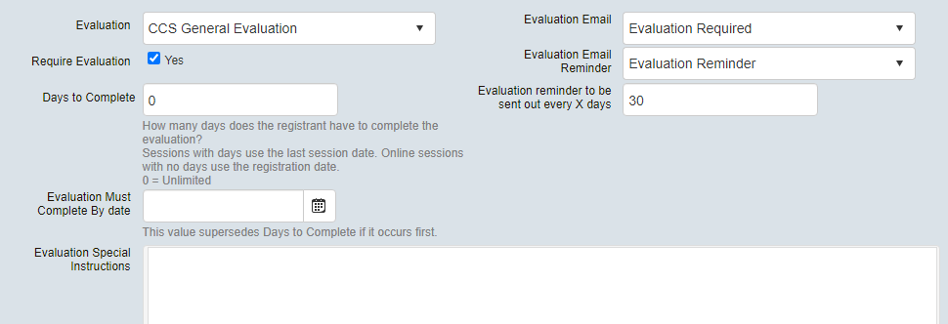

**Days to Complete-**To allow participants the most flexibility Leave “0” in this field. If you set a date the evalaution must be completed by, please do not choose a date earlier than June 30th.

**Contact Name-**Select a name from the drop-down menu.

**Instructor –** All admin. users in the system are listed as available instructors. Please scroll to find your name, click on your name and the click the arrow poiting right to populate the Selected Instructors box. If a teacher or outside presenter is being used, then type the name in the Add Temporary Instructor Box and click Add Instructor.

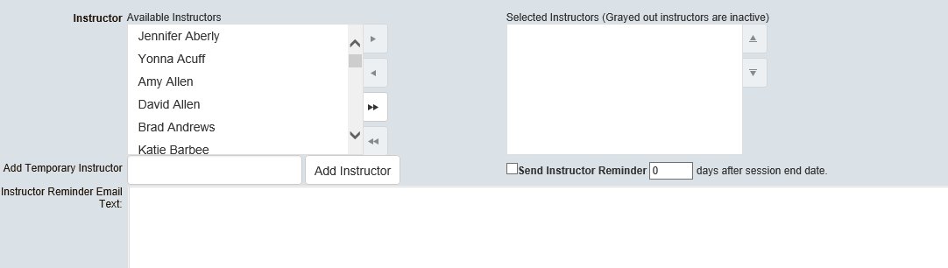

**Send Instructor Reminder –** Check the box, select the number of days after the session end date, and type the email in the box provided. It is a good way to send yourself a reminders after a session to mark attendance.

**Special Instructions**– Not a required field You may wish to use this text box to communicate information to registrants. It will be included in the email confirmation registrants receive (if enabled above) and displayed on the registration page. For example, you may want to remind them to bring their CCS device. You could also post an assignment here to be completed prior to the event.

**Important Information**– Currently, the information entered here displays on the registration page, but ***is not*** included in the email confirmation registrants received after registering.

**Resgistration Restricted To – Please do not use these fields.**

**Add Incomplete –** You may use this anytime it appears in a form to save your work to come back to later.

**Save as Complete –** Click save as complete when you have finished developing the session.

Once your event is saved, back on the main Event Session page, you should be able to search for and see your event. From this page, you can right click on the chain icon to copy the session link. You can paste the link in an email to send directly to individuals that need to register for the event. You can also access the link by clicking on the pencil icon under Edit. The link will be at the top of the Event screen.

